PARISH COUNCIL MTG: Mells July 2025

Number of Crimes by Offence Type:

No crimes to report for the month of July

Number of Crimes Trend:

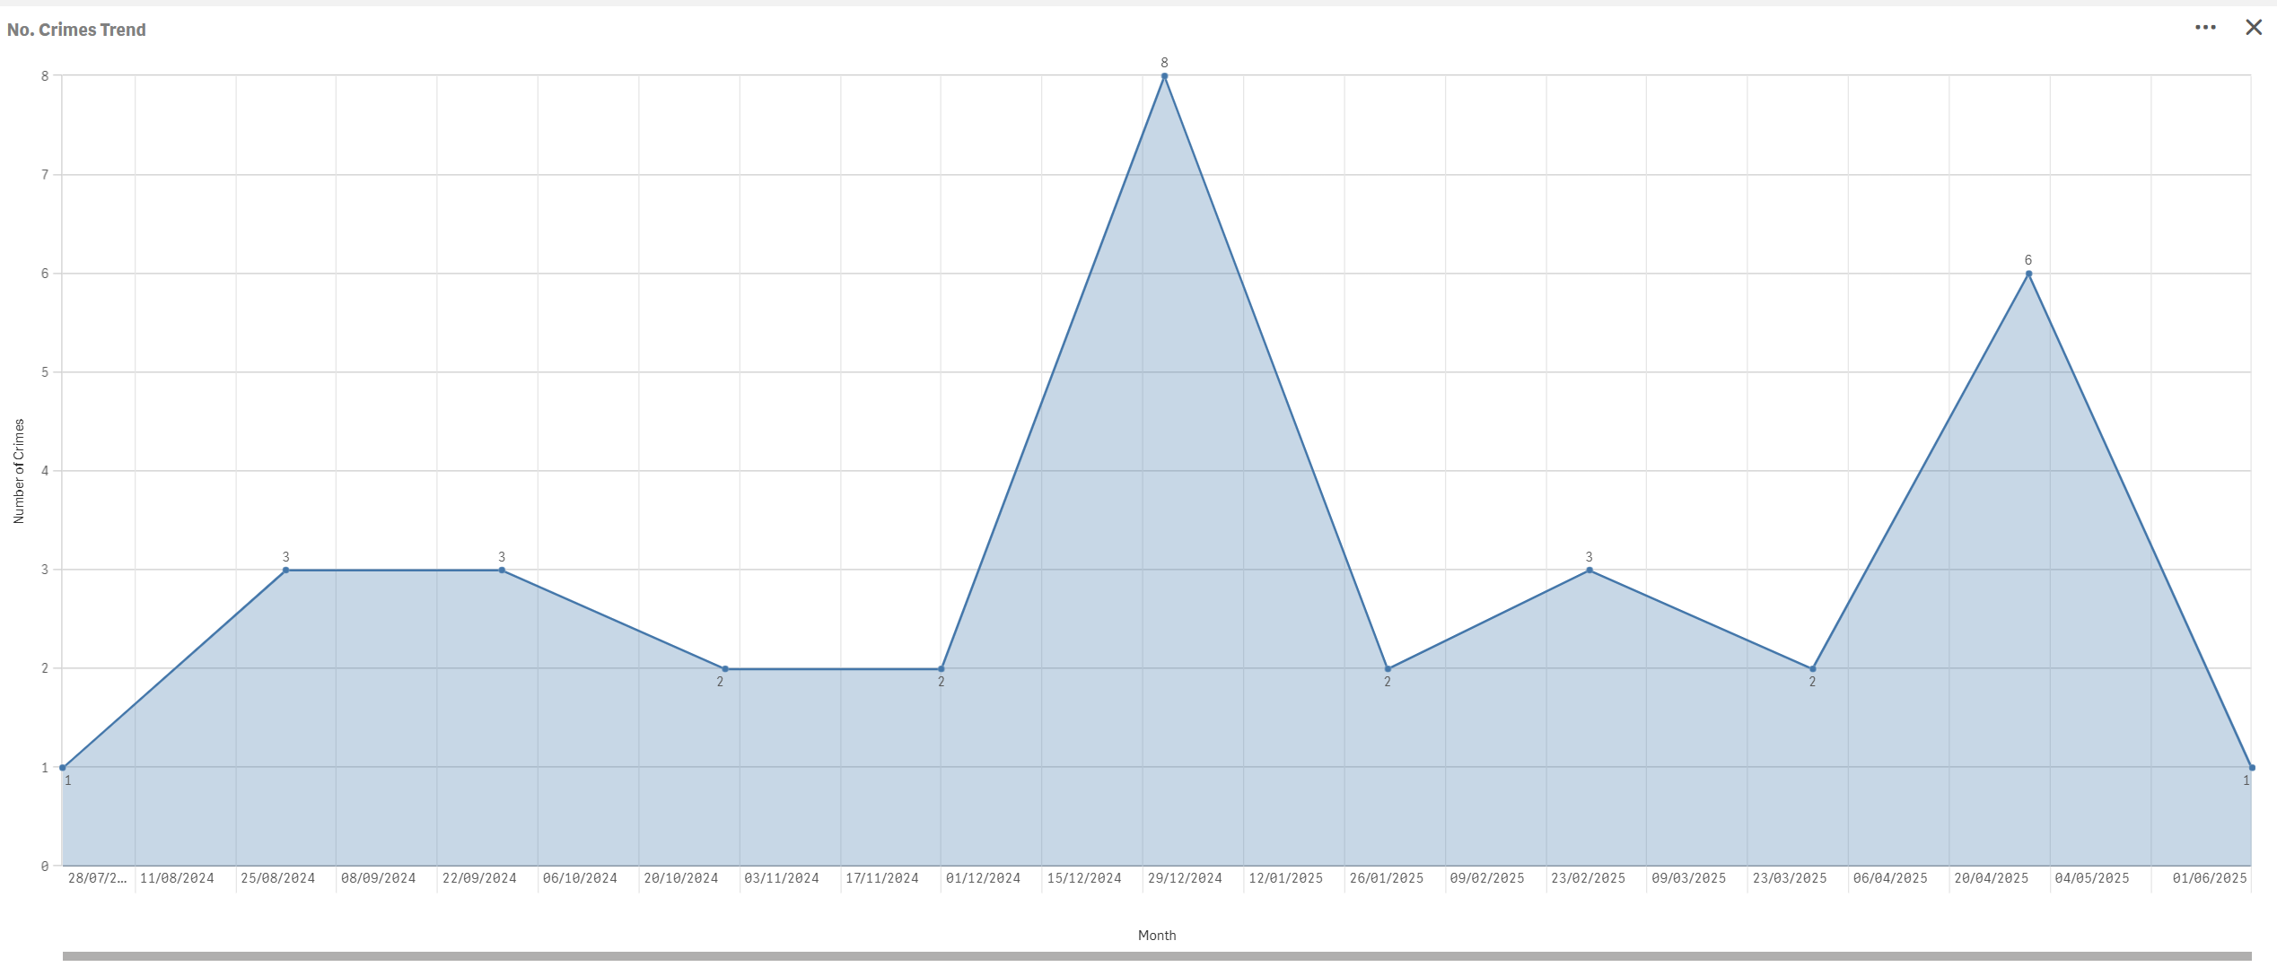

CURRENT PACT PRIORITIES:

Maintain a visible Police presence in Mells alongside monthly beat Surgeries in Mells Cafe

FUTURE PACT PRIORITIES:

Regular foot patrols are ongoing and productive community engagement.
Please remember to report Anti-Social-Behaviour and drug related incidents to 101 or 999, respectively.

OVERALL CRIME TRENDS

None of significant note

